**GANPAT UNIVERSITY**

**U.V.PATEL COLLEGE OF ENGINEERING & TECHNOLOGY**

**Department of Computer Science and Engineering**

**B.Tech 1ST  Semester   Subject – ESFP**

**First Name:Kishan patel       Enrollment Number:  T14012121008                   Stream :BDA**

**Practical – 3                                                                           Date:27/08/14**

Goal

**Practical -2**

**Objectives :**

**1. Write a program to print ASCII values of all backslash characters and white space on screen in following format :**

**The ASCII value of ‘\t’ is : 9**

**(Hint : you can verify your ASCII values with the help of a table for ASCII values from text book)**

**1.1**

**Code**

#include<stdio.h>

#include<conio.h>

void main()

{

char a,b,c,d,e,f,g,h,i,j,k,l,m;

a='\a';

b='\b';

c='\f';

d='\n';

e='\r';

f='\t';

g='\v';

h='\\';

i='\'';

j='\"';

k='\?';

l='\N';

m='\XN';

clrscr();

printf("\nThe Ascii value of \\a is :%d",a);

printf("\nThe Ascii value of \\b is :%d",b);

printf("\nThe Ascii value of \\f is :%d",c);

printf("\nThe Ascii value of \\n is :%d",d);

printf("\nThe Ascii value of \\r is :%d",e);

printf("\nThe Ascii value of \\t is :%d",f);

printf("\nThe Ascii value of \\v is :%d",g);

printf("\nThe Ascii value of \\\ is :%d",h);

printf("\nThe Ascii value of \\' is :%d",i);

printf("\nThe Ascii value of \\\" is :%d",j);

printf("\nThe Ascii value of \\\? is :%d",k);

printf("\nThe Ascii value of \\N is :%d",l);

printf("\nThe Ascii value of \\XN is :%d",m);

getch();

}

Screenshot:-

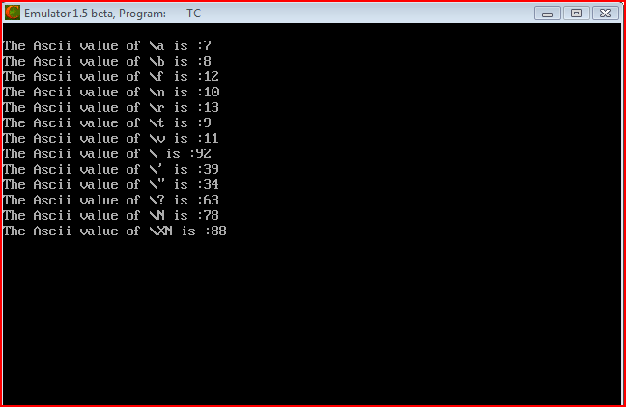



**2. Explain different data types available in C**

Ans:-

There are 4 data types in C language. They are:-

int – This data type is used to define an integer number (-….-3,-2,-1,0,1,2,3….). A single integer occupies 2 bytes.

char – Used to define characters. A single character occupy 1 byte.

float – Used to define floating point numbers (single precision). Occupies 4 bytes.

double – Used for double precision floating point numbers(double precision). Occupies 8 bytes.

Primitive data types are the first form – the basic data types (int,char,float,double).

Derived data types are a derivative of primitive data types known as arrays, pointer and function.

User defined data types are those data types which are defined by the user/programmer himself.

**3. Explain about C Tokens in brief.**

Ans:-

C tokens are the basic buildings blocks in C language which are constructed together to write a C program.

Each and every smallest individual units in a C program are known as C tokens.

C tokens are of six types. They are,

Keywords               (eg: int, while),

Identifiers               (eg: main, total),

Constants              (eg: 10, 20),

Strings                    (eg: “total”, “hello”),

Special symbols  (eg: (), {}),

Operators              (eg: +, /,-,*)

2.Identifiers in C language:

Each program elements in a C program are given a name called identifiers.

Names given to identify Variables, functions and arrays are examples for identifiers. eg. x is a name given to integer variable in above program.

Rules for constructing identifier name in C:

First character should be an alphabet or underscore.

Succeeding characters might be digits or letter.

Punctuation and special characters aren’t allowed except underscore.

Identifiers should not be keywords.

3. Keywords in C language:

Keywords are pre-defined words in a C compiler.

Each keyword is meant to perform a specific function in a C program.

Since keywords are referred names for compiler, they can’t be used as variable name.

**4. Explain about backslash characters in C.**

Ans:-c supports some special baclslash character constants that are used in output function .for eg the symbol '/n' stands for new line character. a list of such backslash character are as follows :-

'/a' means auidible alert ,'/b' means backspace,'/f' means form filled,'/n' new line,'/r' means carriege return, '/t' means horizontal tab, '/v' means vertical tab,'/" means single quote, '/"' means double quote, '/?' means question mark, '//' means backslash,'20' means null.

Here each one of them represents one character,although they consist of two characters.these characters are known as escape sequences.